Ex.no:5b | DATA VISUALIZATION USING MATPLOTLIB –  SALES DATA

AIM
To visualize and analyze the World Happiness dataset, Country Behavior and people Analysis dataset using Line Chart, Bar Chart, and Pie Chart with Matplotlib to understand booking trends, hotel-type comparisons, and market segment distribution.

ALGORITHM
Step 1: Import Pandas and Matplotlib libraries.
Step 2: Download the World Happiness dataset using KaggleHub.
Step 3: Select the happiness score column and plot its distribution using a Histogram.
Step 4: Select GDP per capita and happiness score and plot their relationship using a Scatter Plot.
Step 5: Group the dataset according to hotel type and calculate the number of bookings for each hotel.
Step 6: Plot the happiness score using a Box Plot to identify its spread and outliers.
Step 7: Add suitable titles and axis labels.
Step 8: Plot the market segment distribution using a Pie Chart.
Step 9: Display the visualizations.

CODE
# Import libraries
import pandas as pd
import os
import glob
import kagglehub
import matplotlib.pyplot as plt

# --------------------------------
# Download latest version
# --------------------------------
path = kagglehub.dataset_download(
"yadiraespinoza/world-happiness-2015-2024"
)

print("Path to dataset files:", path)

# --------------------------------
# Load all CSV files
# --------------------------------
csv_files = glob.glob(
os.path.join(path, "**", "*.csv"),
recursive=True
)

dataframes = []

for file in csv_files:
temp = pd.read_csv(
file,
encoding="latin1",
low_memory=False
)

# Store the file/year information
temp["Year_File"] = os.path.basename(file)

dataframes.append(temp)

# Combine all CSV files
df = pd.concat(
dataframes,
ignore_index=True
)

print("Dataset Shape:", df.shape)
print(df.head())

# --------------------------------
# Find Happiness Score column
# --------------------------------
if "Life Ladder" in df.columns:
score_column = "Life Ladder"
elif "Ladder score" in df.columns:
score_column = "Ladder score"
elif "Happiness Score" in df.columns:
score_column = "Happiness Score"
else:
raise ValueError(
"Happiness score column not found"
)

# --------------------------------
# Find GDP column
# --------------------------------
if "Log GDP per capita" in df.columns:
gdp_column = "Log GDP per capita"
elif "GDP per capita" in df.columns:
gdp_column = "GDP per capita"
elif "Logged GDP per capita" in df.columns:
gdp_column = "Logged GDP per capita"
else:
raise ValueError(
"GDP per capita column not found"
)

print("Happiness Score Column:", score_column)
print("GDP Column:", gdp_column)

# --------------------------------
# 1. Histogram – Happiness Score
# --------------------------------
plt.figure(figsize=(10, 5))

plt.hist(
df[score_column].dropna(),
bins=30
)

plt.title("Distribution of Happiness Score")
plt.xlabel("Happiness Score")
plt.ylabel("Frequency")

plt.show()

# --------------------------------
# 2. Scatter Plot – GDP vs Happiness
# --------------------------------
plt.figure(figsize=(10, 5))

plt.scatter(
df[gdp_column],
df[score_column],
alpha=0.5
)

plt.title(
"Relationship Between GDP per Capita and Happiness Score"
)

plt.xlabel("GDP per Capita")
plt.ylabel("Happiness Score")

plt.show()

# --------------------------------
# 3. Box Plot – Happiness Score
# --------------------------------
plt.figure(figsize=(8, 5))

plt.boxplot(
df[score_column].dropna()
)

plt.title("Box Plot of Happiness Score")
plt.ylabel("Happiness Score")

plt.show()

OUTPUT
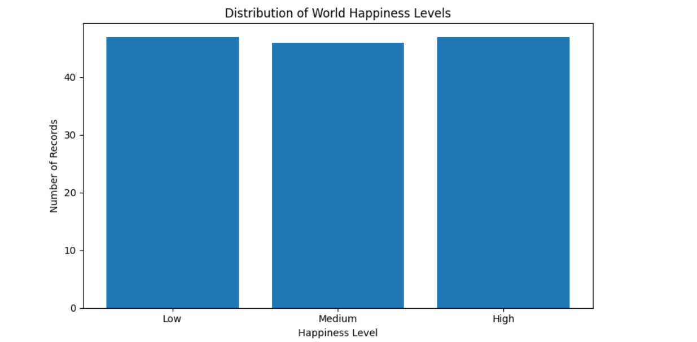

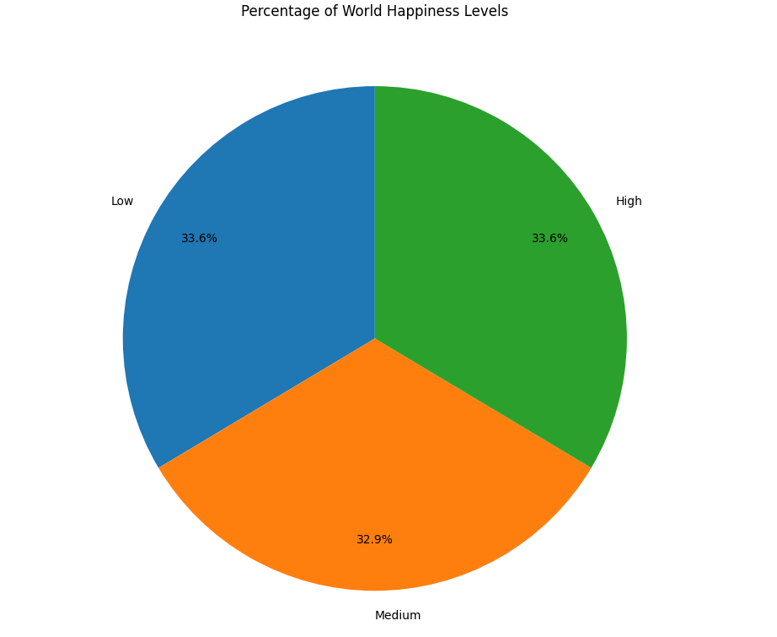

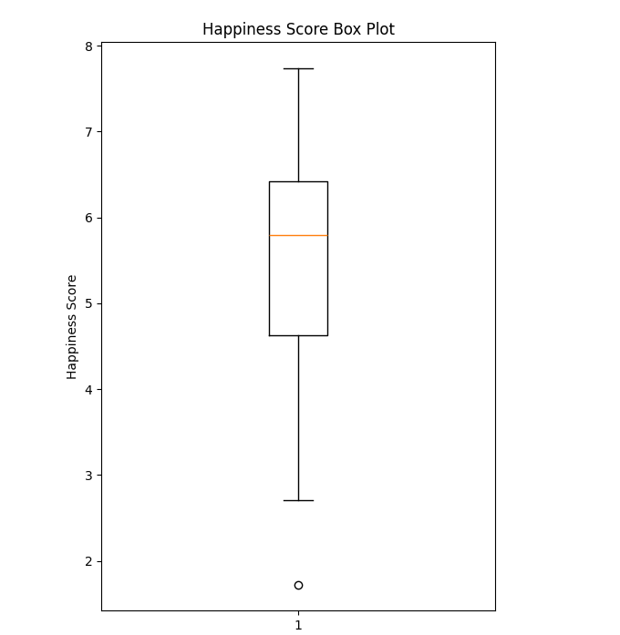

RESULT

